Chapter 9 The Standard Model
Chapter Test Total marks 40
A data sheet with appropriate physics constants will be provided for this test.
Question 1
a The Standard Model explains three of the four fundamental forces in terms of an exchange of force-carrying particles called gauge bosons. Complete the table below for the four forces. Gravity is completed as an example. (8 marks)

Force | Nature of force | Range over which force acts (m) | Force carrier  (gauge bosons)
 | causes radioactive decay |  | W⁺, W⁻ and Z
 | responsible for both electric and magnetic fields exerting forces of attraction or repulsion
 |  | ~10⁻¹⁵
gravity | a force of attraction between any two objects with mass | infinite | graviton  (theoretical and unobserved)

b Rank these four fundamental forces in order of their strength from strongest to weakest. (1 mark)

Question 2
It was observed in the 1930s that when a neutron decayed, a proton and an electron were produced. It was consistently observed that the energy of the electron was less than expected. To avoid the violation of two fundamental principles of physics, Wolfgang Pauli suggested that another particle, undetectable at the time, was produced during neutron decay. This particle was later discovered and is now called an antineutrino.
Name the two fundamental principles of physics that would have been violated if the antineutrino was not produced during neutron decay. (2 marks)

Question 3
Which of the four fundamental interactions (strong nuclear, weak nuclear, electromagnetic and gravity) does:
a a proton take part in? (1 mark)

b an electron take part in? (1 mark)

c a neutron take part in? (1 mark)

Question 4
A neutron is composed of two down quarks and one up quark. The mass of a neutron is greater than the sum of the masses of its component quarks. Account for this discrepancy in mass. (2 marks)

Question 5
Particle accelerators have contributed significantly to our understanding of the Standard Model of particle physics. Linear accelerators accelerate charged particles to high speeds, directing them to hit a fixed target. The products and energy of the collisions are then studied.
The diagram below represents part of a linear accelerator responsible for accelerating charged particles. The cylinders are connected to an alternating current.

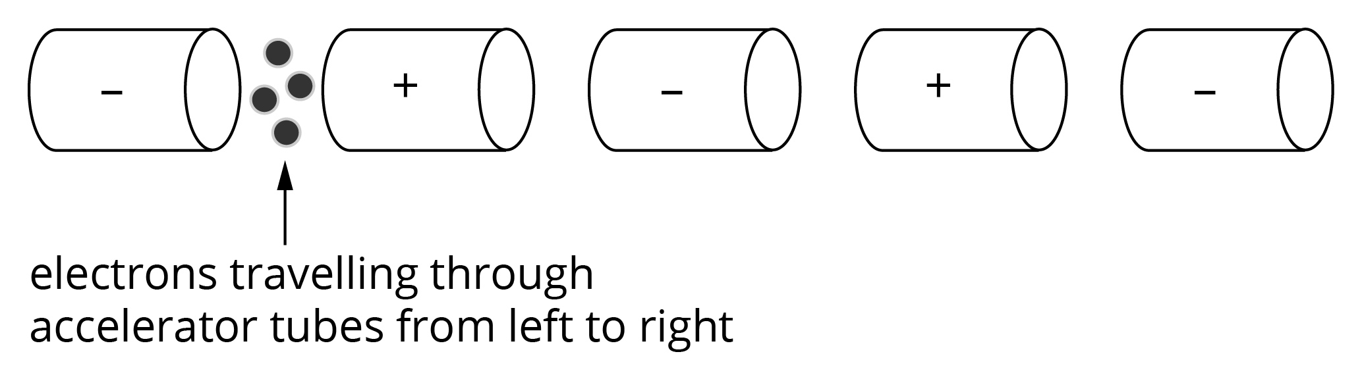

a Explain how the series of tubes accelerate the electrons. Your explanation needs to indicate the role of the alternating current. (3 marks)

Synchrotrons are able to accelerate particles to higher speeds than linear accelerators. As well, synchrotrons allow particles travelling at the same speed in opposite directions to collide rather than only striking a fixed target.
b What advantage does the collision of particles travelling at the same speed in opposite directions provide in the study of particle physics have over a particle striking a fixed target? (3 marks)

c Another advantage of high-speed collisions is improved resolution to study finer structure. Explain why high speeds can achieve improved resolution. Support your answer with an appropriate equation. (2 marks)

Question 6
In any particle interaction, the lepton number and baryon number must be conserved. All leptons have a lepton number of positive one (i.e. L = +1) and antileptons have a lepton number of negative one (i.e. L = −1). The table below gives leptons and their antiparticles.
Lepton | Lepton symbol | Antilepton symbol
Electron | e⁻ | e⁺
Electron neutrino
Muon | μ⁻ | μ⁺
Muon neutrino
Tau | τ⁻ | τ⁺
Tau neutrino
All baryons have a baryon number of positive one (i.e. B = +1) and antibaryons have a baryon number of negative one (i.e. B = −1). Mesons have a baryon number of zero (i.e. B = 0). The table below gives baryons, mesons and their antiparticles.
 |  | Symbol | Antiparticle symbol
Mesons | pion | π⁺ | π⁻
 |  | π° | π°
Baryons | proton | p
 | neutron | n
 | lambda | Λ°
 | sigma | Σ°

a Complete the particle interactions indicated below. Explain your choice of particle.

i μ⁻ → e⁻ + + _____ (3 marks)

ii p + _____ → p + e⁻ + ν_{e} (4 marks)

b Describe the particle interaction represented by the Feynman diagram below. Your description needs to name the particles and the type of force carrier involved.
(3 marks)
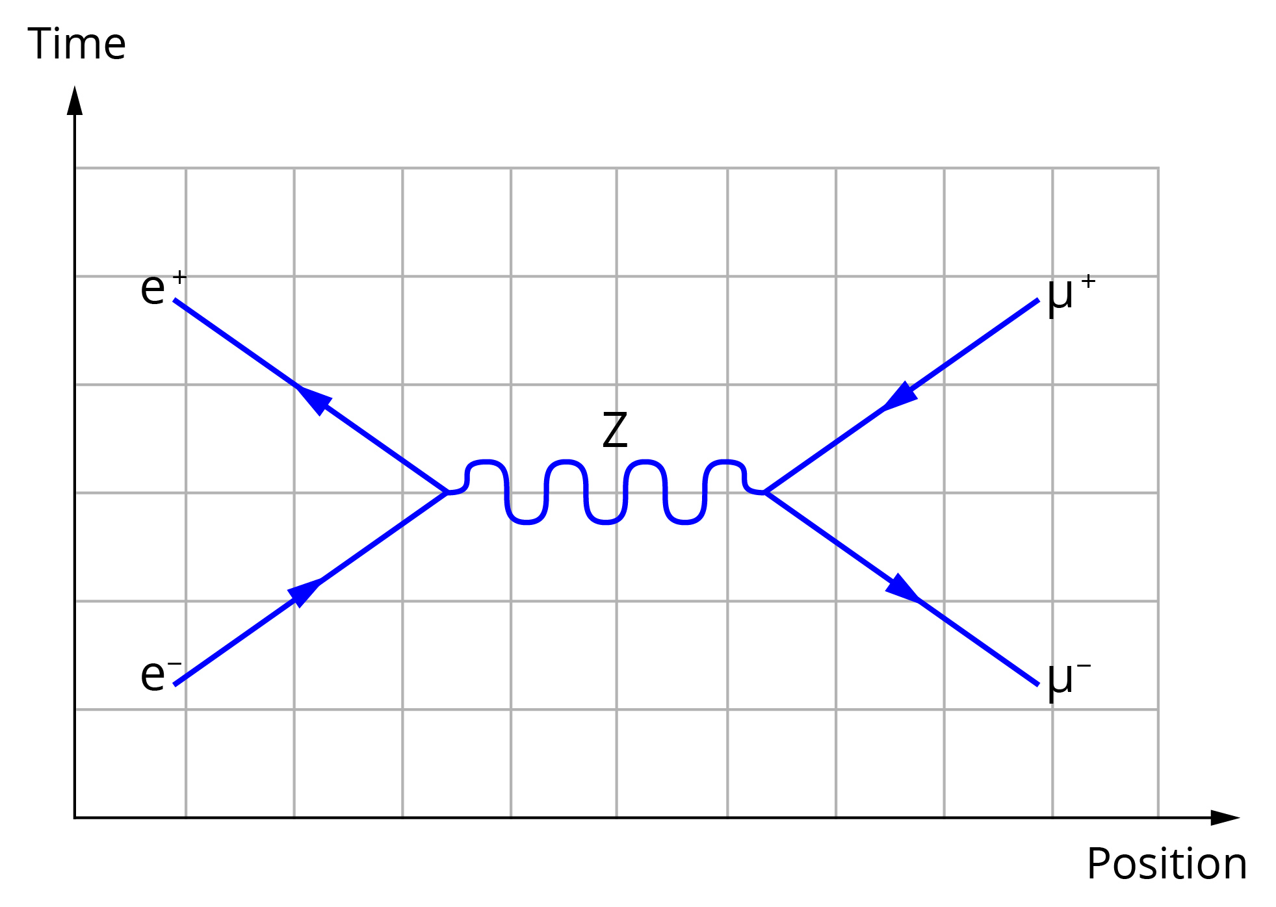

Question 7
When the red shift in the spectra from distant stars was first observed, it was interpreted as a Doppler shift. Explain why this is no longer the accepted interpretation for the red shift. Your explanation needs to indicate what causes the change in the wavelength of light that originated from distant stars. (2 marks)

Question 8
One of the pieces of evidence found to support the Big Bang theory for the evolution of the universe is the existence of the cosmic background microwave radiation.
a Why is this radiation in the microwave region of the electromagnetic spectrum?
(2 marks)

In 1964 Arno Penzias and Robert Wilson measured uniform background radiation in all directions and so discovered the cosmic background radiation. Later, more detailed measurement has shown small variations in the temperature of the cosmic background radiation.

b Why is this small variation in temperature important in explaining the universe as it is observed to exist? (2 marks)

